KFC’S DOUBLE CHICKEN DYNAMITE PUTS NOODLES BETWEEN CRISPY CHICKEN. AND WE’RE NOT QUESTIONING IT.

~Introducing the Double Chicken Dynamite - priced starting at just ₹299~

~Indulge in the all-chicken no bun burger, packed with Korean noodles, signature spicy mayo & cheese in the center, topped with bold spices~

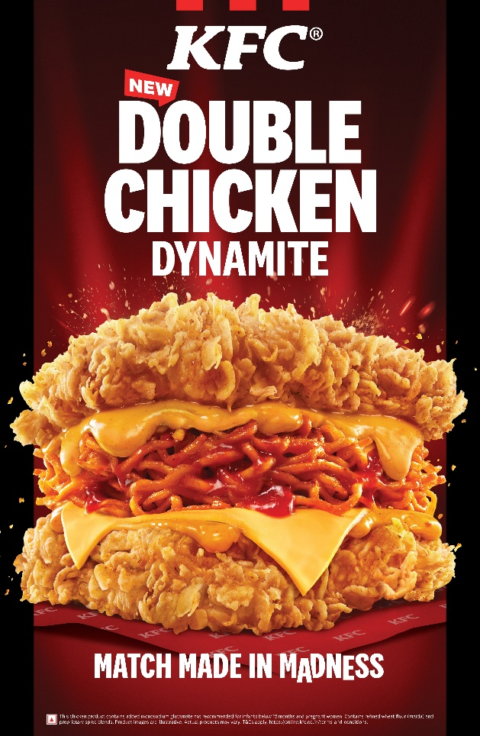

National, 24th June 2026: Some things shouldn't make sense. And yet... somehow, they always do.

Chocolate samosas.
Paan ladoos.
Achar with ice-cream.

And now – Korean noodles, placed right between two crispy chicken fillets.

India has always had a love for unusual food combinations – ones that feel unexpected (and shocking) at first and then win you over after the first bite. From streetside innovations to food experiments for YouTube, unlikely pairings have a way of finding their way into India’s hearts.

KFC India taps into this instinct with the launch of the all-new Double Chicken Dynamite, where two worlds collide to create a new menu offering that is pure madness.

The all-chicken no bun burger has two crispy Zinger fillets loaded with droolworthy Korean noodles, signature spicy mayo & cheese and is topped with bold spices, creating a mad combination that's crunchy, cheesy and unapologetically indulgent.

Whether you are a chicken lover, a noodle lover, or simply someone who believes great food happens when rules are broken, the Double Chicken Dynamite is here to prove that sometimes "Why not?" is the best answer.

29th June onwards, the all-new Double Chicken Dynamite will be available across all 1400+ KFC restaurants in India for dine-in & takeaway, as well as via the KFC app, website (https://online.kfc.co.in/) and via leading food delivery apps.

So, what are you waiting for? It’s time to indulge in the madness with the Double Chicken Dynamite!

About KFC
KFC, a subsidiary of Yum! Brands, Inc. (NYSE: YUM.), is a global chicken restaurant brand with a rich, decades-long history of success and innovation. It all started with one cook, Colonel Harland Sanders, who created a finger lickin’ good recipe more than 80 years ago, a list of secret herbs and spices scratched out on the back of the door to his kitchen. Today we still follow his formula for success, with real cooks breading and freshly preparing our delicious chicken by hand in more than 26,000 restaurants in over 145 countries and territories around the world.

For more information, visit https://online.kfc.co.in/ or contact Burson India BursonKFCBrandsteam@bursonglobal.com

